Part 1 — Create EC2 Instance
Login to Amazon Web Services Console
Go to Amazon EC2
Steps
- Click Launch Instance
- Configure:
Setting | Value
Name | studentname-ec2
AMI | Amazon Linux / Ubuntu
Instance type | t2.micro
Key pair | create or use existing
Network | default VPC
Security group | allow SSH (22)
- Storage
Rename root volume:
studentname-ec2-root-volume
- Launch instance
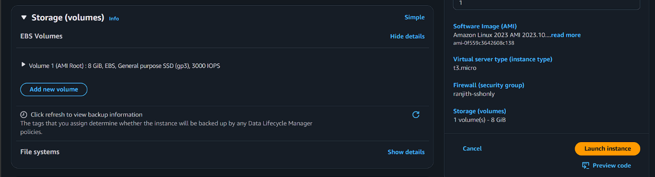

Part 2 — Create Data EBS Volume
Go to EC2 → Volumes
Click Create Volume
Setting | Value
Name | studentname-ec2-data-volume
Size | 5 GiB
Type | gp3
Availability Zone | Same as EC2
Create volume.
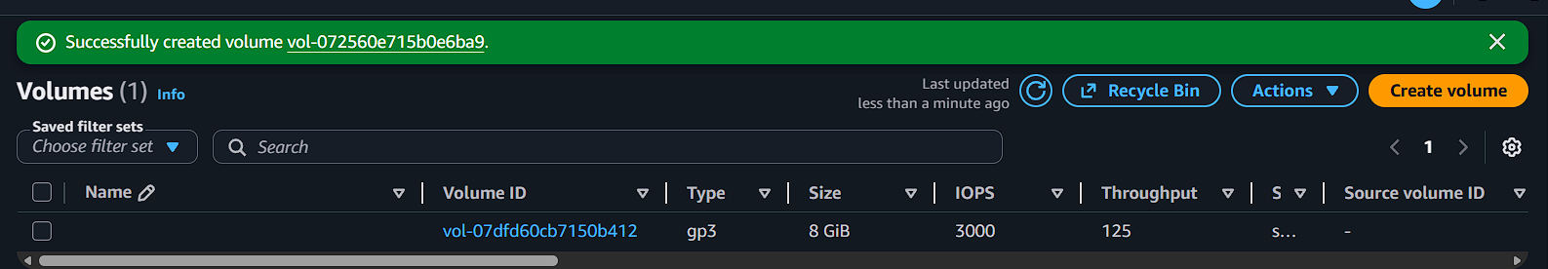

Part 3 — Attach Volume to EC2
Select volume → Actions → Attach Volume
Setting | Value
Instance | studentname-ec2
Device name | /dev/sdf
Attach.
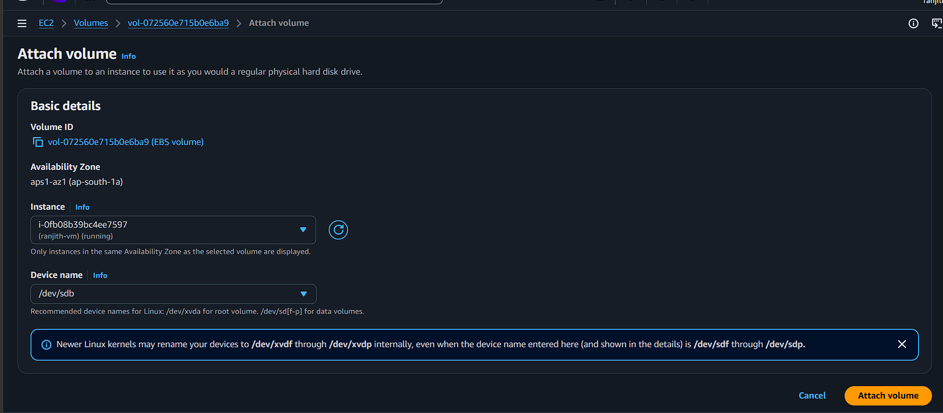

Part 4 — Connect to EC2
SSH into instance
ssh -i key.pem ec2-user@public-ip
Check disks
lsblk
Example output
xvda 8:0 0 10G 0 disk
└─xvda1
xvdf 8:80 0 5G 0 disk
xvdf = new EBS disk

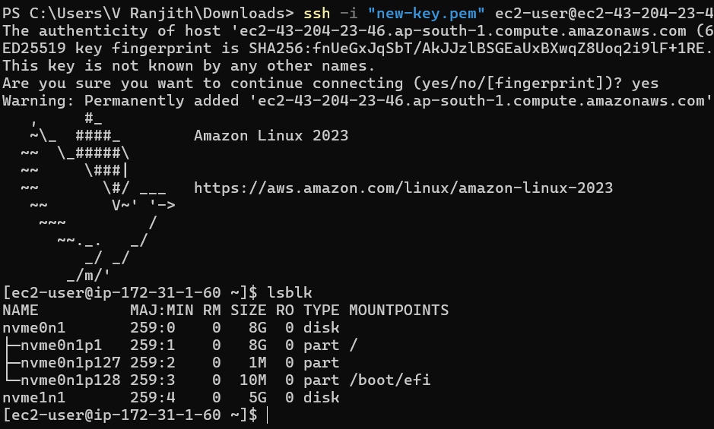

Part 5 — Create Filesystem
Create filesystem
sudo mkfs -t ext4 /dev/xvdf
Verify
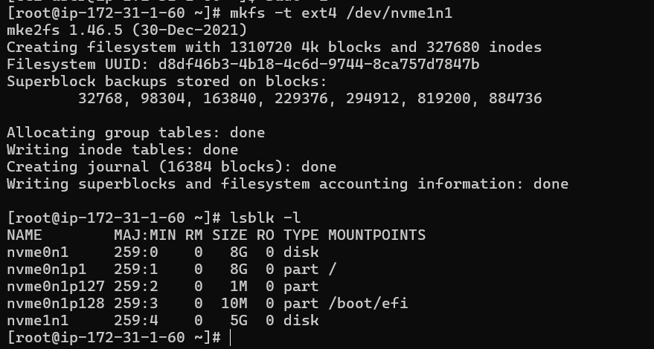
lsblk -f

Part 6 — Create Mount Directory
sudo mkdir /data
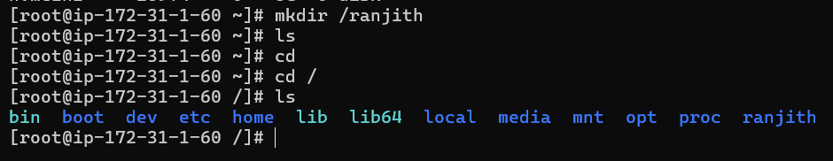

Part 7 — Mount Volume
sudo mount /dev/xvdf /data
Verify
df -h
Expected
/dev/xvdf 5G 24M /data
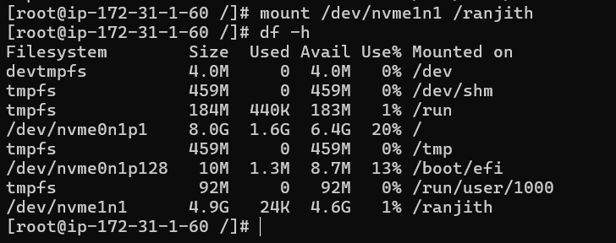

Part 8 — Add Data
Create test file
sudo touch /data/testfile
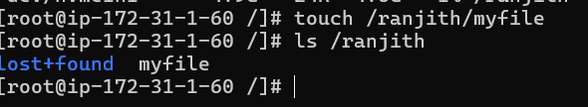
Add data
echo "AWS EBS Lab Practice" | sudo tee /data/lab.txt
Verify
ls /data
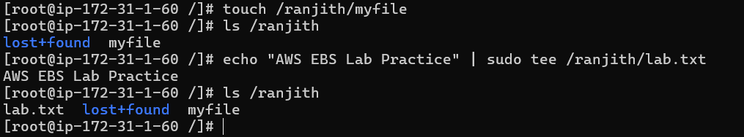

Part 9 — Permanent Mount (fstab)
Get UUID
sudo blkid /dev/xvdf
Example
UUID=ab23cd34-xxxx
Edit fstab
sudo vi /etc/fstab
Add line
UUID=xxxx /data ext4 defaults,nofail 0 2

Part 10 — Validate fstab
Unmount first
sudo umount /data
Mount using fstab
sudo mount -a
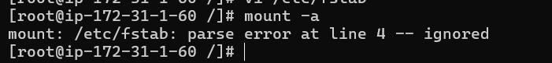
Check
df -h
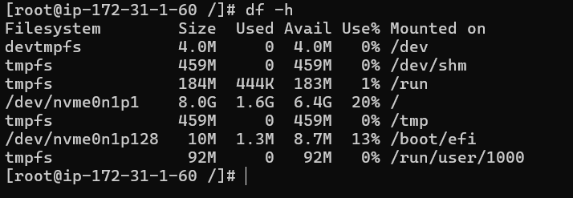

Part 11 — Reverse Process (Cleanup)
Step 1 Remove fstab entry
Edit file
sudo vi /etc/fstab
Delete /data line.

Step 2 Unmount Volume
sudo umount /data
Verify
df -h

Step 3 Delete Data Directory
sudo rm -rf /data

Part 12 — Detach EBS Volume
Go to EC2 → Volumes
Select
studentname-ec2-data-volume
Actions → Detach Volume
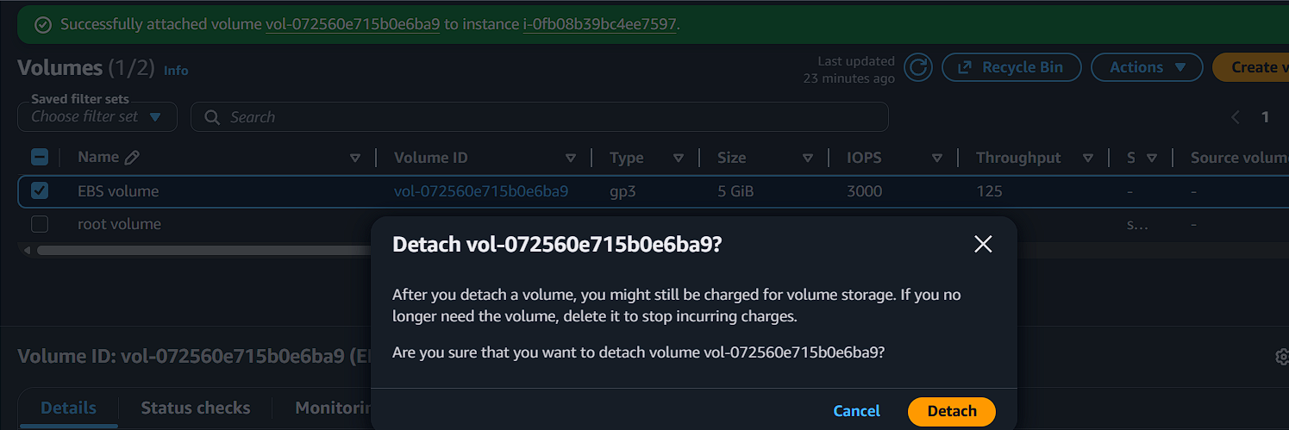

Part 13 — Delete Volume
After detach
Delete Volume
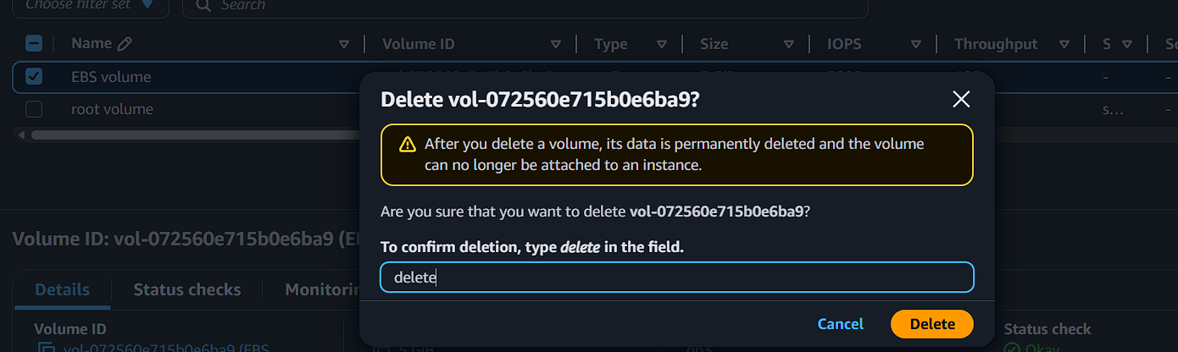

Part 14 — Terminate EC2
Go to Instances
Select
studentname-ec2
Click
Terminate Instance
Root volume will also be deleted (if delete-on-termination enabled).
